CPCS 380 Operating System Principles

Midterm Exam Study Notes

Chapter 1 – Introduction
Know the definition of an operating system
A program that manages a computer’s hardware acting as an intermediary between the computer user and the hardware.
- Resource allocator: manages all resources and decides between conflicting requests for efficient and fair resource use
- Control program: controls execution of programs to prevent errors and improper use of the computer
Familiar with the general system structure
- Hardware
  - Provides basic computing resources
- Operating Systems
  - Controls and coordinates use of hardware among various applications and users
- Application Programs
  - Define the ways in which the system resources are used to solve the computing problems of the users
- Users
  - People, machines, and other computers
Computer startup (i.e. bootstrap programs)
Initializes all aspects of the system, loads operating system kernel and starts execution. Bootstrap is stored in firmware.
Computer system organizations (CPUs, device controllers, bus memory cycles)
Consists of 1 or more CPUs and a number of device controllers connected through a common bus that provides access to main memory. Memory controller synchronizes access to shared memory between the CPUs and device controllers.
Interrupts and Interrupt Handling
Interrupts: transfers control to the interrupt service routine through the interrupt vector which contains addresses of all the service routines. An OS is interrupt driven. Trap/exception is a software-generated interrupt.
Interrupt Handling: OS preserves the state of the CPU by stored registers and the program counter. Determines what type of interrupt occurred (polling or vectored interrupt system).
I/O Structure
- System calls
  - Request to the OS to allow the user to wait for I/O completion
- Device-status tables
  - Contains entry for each I/O device indicating its type, address, and state.
Storage Structure
- Storage Hierarchy
  - 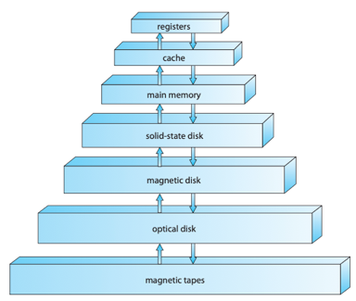
  - Organized by speed, cost, and volatility
- Caching
  - Data stored in main memory is copied into faster memory on a temporary basis for quick access (main memory can be viewed as a cache for secondary storage).
Direct Memory Access Structure
- How DMA works
  - Used for high-speed I/O devices able to transmit information at close to memory speeds
  - Device controller transfers blocks of data from buffer storage directly to main memory without CPU intervention
  - Only one interrupt generated per block
Computer-System Architecture
- Symmetric Multiprocessing Architecture
  - Each processor performs all tasks
  - 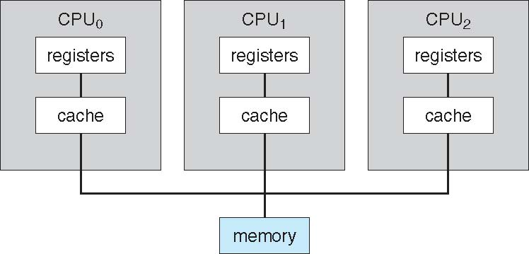
- Dual-Core Design
  - Multi-chip and multicore
  - System containing all chips
  - 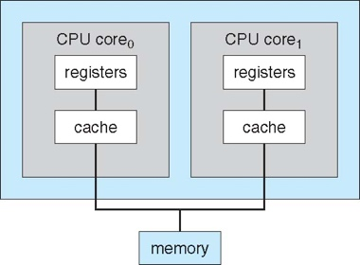
- Clustered Systems
  - Multiple systems working together
    - Usually share storage via SAN (storage-area network)
    - Provides a high-availability service which survives failures
    - Can be used for HPC (high-performance computing)
  - 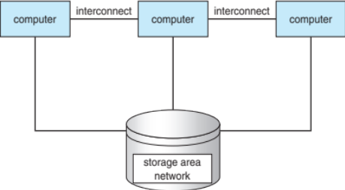
Operating System Structure
- Operating-System Operations
  - Interrupt driven
  - Dual-mode
- Process Management
  - Process is a program in execution
  - Create/delete user/system processes
  - Suspending/resuming processes
  - Allow for process synchronization
  - Allow for process communication
  - Allow for deadlock handling
- Memory Management
  - Determine what is in memory and when
  - Keep track of what memory is being used and by whom
  - Decide which processes and data to move into/out of memory
  - Allocate/deallocate memory space
- Storage Management
  - File-System Management
  - File: abstracts physical properties to logical storage unit
- I/O Subsystem
  - Device-driver interface
  - Memory management of I/O
- Protection & Security
  - Protection: any mechanism for controlling access of processes or users to resources defined by the OS
  - Security: defense of the system against internal/external attack

Chapter 2 – Operating-System Structures
OS Services
- User interface
  - CLI (command-line)
  - GUI (graphical user interface)
  - Batch
- Program execution
  - The system must be able to load a program into memory and run that program and end execution
- I/O operations
  - A running program may require I/O, which may involve a file or I/O device
- File-system manipulation
  - Programs need to read and write files
- Communications
  - Processes may exchange information on the same computer or over a network
- Error Detection
  - OS needs to constantly be aware of possible errors
- Resource allocation
  - Resources must be allocated to multiple users/jobs
- Accounting, Protection and Security
  - Accounting: Keep track of which sers how much and what kinds of resources
  - Protection: ensure access to resources is controlled
  - Security: require user authentication to defend against invalid access
Operating Systems Interface
- CLI or GUI
  - Shells (i.e. csh, bash, …)
  - CLI allows direct command entry
  - GUI is a user-friendly desktop metaphor interface
System Calls/Programs
- APIs
- Application Programming Interface allows access to programs from high-level rather than direct system call use
  - System Call Implementation
    - System-call interface: maintains a table indexed according to a list of numbers associated with each system call
    - System-call interface invokes the intended system call in OS kernel and returns status of the system call

Chapter 3 – Processes
Process Concept
- Text section, data section, program counter, stack, heap
  - Text section: the program code
  - Program counter: contains the address of the current instruction being executed
  - Stack: contains temporary data such as function parameters, return addresses, and local variables
  - Data section: global variables
  - Heap: contains memory dynamically allocated during running time
- Process in memory
  - Stack memory addresses decrease
  - Heap memory addresses increase
  - 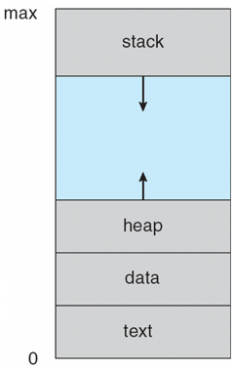
- Process state
  - New: process is being created
  - Running: instructions are being executed
  - Waiting: process is waiting for some event to occur
  - Ready: process is waiting to be assigned to a processor
  - Terminated: process has finished execution
  - 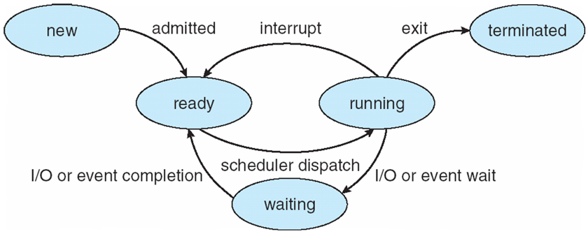
- Process Control Block
  - Data type to store information associated with each process
    - Process state
    - Program Counter
    - CPU registers
    - CPU scheduling information
    - Memory-management information
    - Accounting information
    - I/O status information
- Threads of execution
  - Consider multiple program counters per process, multiple locations can execute at once meaning there are multiple threads of control
Process Scheduling
- Long-term schedulers (job scheduler)
  - Selects which processes should be brought into the read queue
    - Invoked infrequently
    - Controls the degree of multiprogramming
- Short-term schedulers (CPU scheduler)
  - Selects which process should be executed next and allocates CPU
    - Invoked frequently
Context-Switch
Saves the state of an old process and loads the saved state for a new process so that a CPU can switch processes
Context of a process represented in PCB
Creates overhead (no useful work done while switching)
Operation on Processes
- Creation, termination
  - Creation: parent process create children processes, each identified via a process identifier (pid)
  - Termination: process executes last statement and asks OS to delete it using exit()
- Forking processes
Interprocess Communications
- Shared memory
  - Area of memory shared among the process
  - Communication is under user control
  - Synchronization becomes an issue
- Message passing
  - Processes communicate with each other without using shared variables
  - Processes must establish a communication link and exchange messages via send()/receive()
- 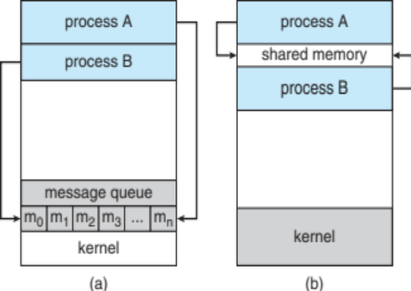
- Independent/Cooperating Processes
  - Independent: process cannot affect or be affected by the execution of another process
  - Cooperating: process can affect or be affected by the execution of another process
- Indirect Communication
  - Mailboxes
    - Has a unique id
    - Process can only communicate if they share a mailbox
- Synchronization
  - Blocking
    - Synchronous
    - Blocking send: sender is blocked until the message is received
    - Blocking receive: receiver is blocked until a message is available
  - Non-blocking
    - Asynchronous
    - Non-blocking send: sender send the message and continues
    - Non-blocking receive: the receiver receives a valid message or a null message
- Buffering
  - Queue of messages attached to the link
- Pipes, Sockets, Remote Procedures Calls (RPCs)
  - Socket: defined as an endpoint for communication
  - Remote Procedure Calls: abstracts procedure calls between processes on networked systems
  - Pipes: acts as a conduit allowing two processes to communicate

Chapter 4 – Threads
Multithreaded Architectures
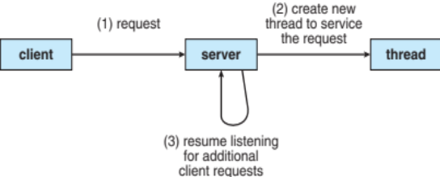
- Benefits
  - Responsiveness: allows continued execution if part of process is blocked
  - Resource Sharing: threads share resources of process (easier than setting up IPC)
  - Economy: cheaper than process creation and thread switching as well as lower overhead than context switching
  - Scalability: process can take advantage of multiple processors
- Multicore programming
  - Challenges
    - Dividing activities
    - Balance
    - Data splitting
    - Data dependency
    - Testing and debugging
  - Parallelism: system can perform more than one task simultaneously
    - Data parallelism: distributes subsets of same data across multiple cores, same operation on each
    - Task parallelism: distributes threads across multiple cores, unique operation with each thread
  - Concurrency: more than one task making progress
  - 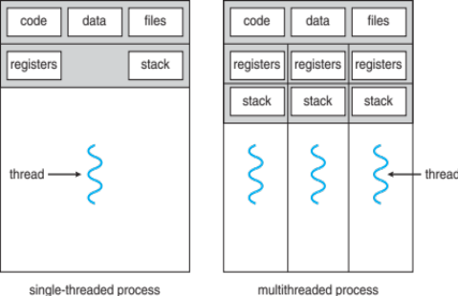
Concurrency/Parallelism
- Amdahl’s Law
  - Identifies gains from adding additional cores to an application that has serial and parallel components
  - 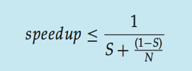
    - S = serial portion
    - N = processing cores
User/Kernel Threads & Multithreading Models
User threads: management done by user-level threads library
Kernel threads: supported by the kernel
- Thread Libraries
  - Provides programmer with API for creating and managing threads
- Pthreads examples
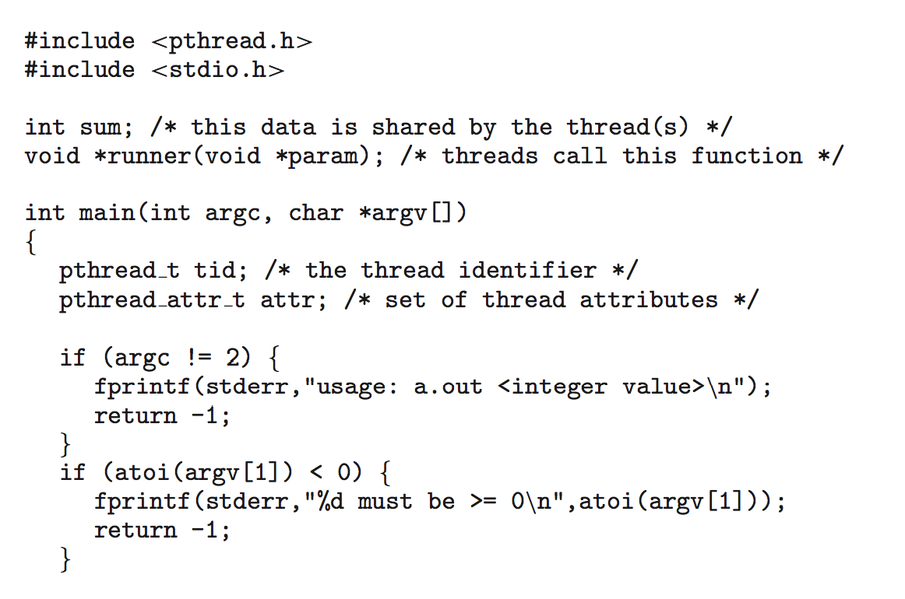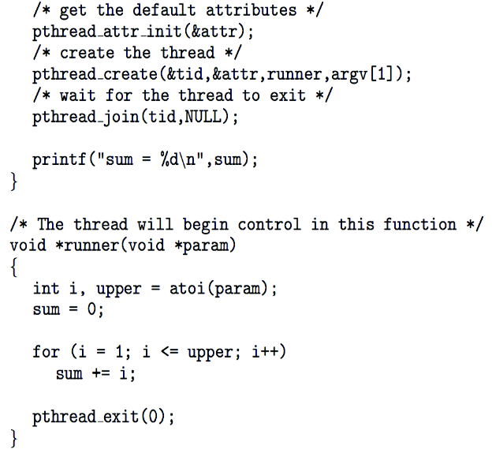
Signal Handling
Signals used to notify a process an event has occurred
Signal handler used to process signals
Thread Cancellation
Terminating a thread before it has finished
Asynchronous cancellation terminates the target thread immediately.
Deferred cancellation allows the target thread to periodically check if it should be cancelled.

Chapter 5 – Process Synchronization

Describe the Critical Section Problem.
Each process must ask permission to enter critical section in entry section, may follow critical section with exit section, then remainder section
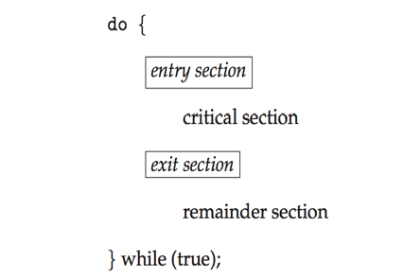
Know the three requirements the critical-section problem must satisfy
- Mutual Exclusion
  - If process in its critical section, then no other processes can be executing their critical sections
- Progress
  - If no process is executing in its critical section and there exist some processes that wish to enter their critical section, then the selection of the processes that will enter the critical section cannot be postponed indefinitely
- Bounded Waiting
  - A bound must exist on the number of times that other processes are allowed to enter their critical sections after a process has made a request to enter its section and before that request is granted

Know the definition of the hardware instructions TestAndSet and Swap
boolean test_and_set (boolean *target)
{
boolean rv = *target;
*target = TRUE;
return rv:
}
do {
while (test_and_set(&lock))
; /* do nothing */
/* critical section */
lock = false;
/* remainder section */
} while (true);
int compare_and_swap(int *value, int expected, int new_value) {
int temp = *value;
if (*value == expected)
*value = new_value;
return temp;
}
do {
while (compare_and_swap(&lock, 0, 1) != 0)
; /* do nothing */
/* critical section */
lock = 0;
/* remainder section */
} while (true);

What is a semaphore? How are the used? How are they implemented?
Synchronization tool that provides more sophisticated ways for process to synchronize their activities.
Integer variable
Accessed through wait() and signal()
Counting semaphore: integer value can range over an unrestricted domain
Binary semaphore: integer value can range only between 0 and 1
Know/Describe some classic problems of synchronization
- Bounded-Buffer Problem
  - n buffers, each can hold one item
  - Semaphore mutex = 1
  - Semaphore full = 0
  - Semaphore empty = n
- Reader-Writers Problem
  - A data set is shared among a number of concurrent processes
  - Readers: can only read from the data set
  - Writers: can read and write
- Dining-Philosophers Problem
  - Philosophers can think and eat
  - Takes 2 chopsticks to eat (access one at a time)
  - Should not interact with neighbors
What are Monitors?
A high-level abstraction that provides a convenient and effective mechanism for process synchronization.
What is an Atomic Transaction?
Atomic = non-interruptible

Chapter 6 – CPU Scheduling
Basic Concepts
- CPU & I/O Bursts
  - Process execution consists of a cycle of CPU execution and I/O wait
CPU Scheduler
- Preemptive/Non-preemptive
  - Non-preemptive: switches from running to waiting state or termation
  - Preemptive: switches from running to ready state or waiting to ready
    - Consider access to shared data
    - Consider preemption while in kernel mode
    - Consider interrupts occurring during crucial OS activities
- Dispatcher
  - Gives control of the CPU to the process selected by the short-term scheduler
    - Switches context
    - Switches to user mode
    - Jumps to proper location in the user program to restart that program
- Scheduling Criteria
  - CPU utilization – keep the CPU as busy as possible
  - Throughput – # of processes that complete their execution per time unit
  - Turnaround time – amount of time to execute a particular process
  - Waiting time – amount of time a process has been waiting in the ready queue
  - Response time – amount of time it takes from when a request was submitted until the first response is produced, not output (for time-sharing environment)
- Scheduling Algorithms
  - FCFS
    - Schedules processes by the order that they arrive in
  - SJF
    - Schedules processes by the order of the processes next CPU burst
  - Priority
    - Schedules processes by a priority number associated with each process
  - RR
    - Each process gets a quantum, after time has elapsed the process is preempted and added to the end of the ready queue
  - Multilevel Queue
    - Ready queue is partitioned into separate queues (foreground and background)
    - Each queue has its own scheduling algorithm (foreground – RR and background – FCFS)
    - 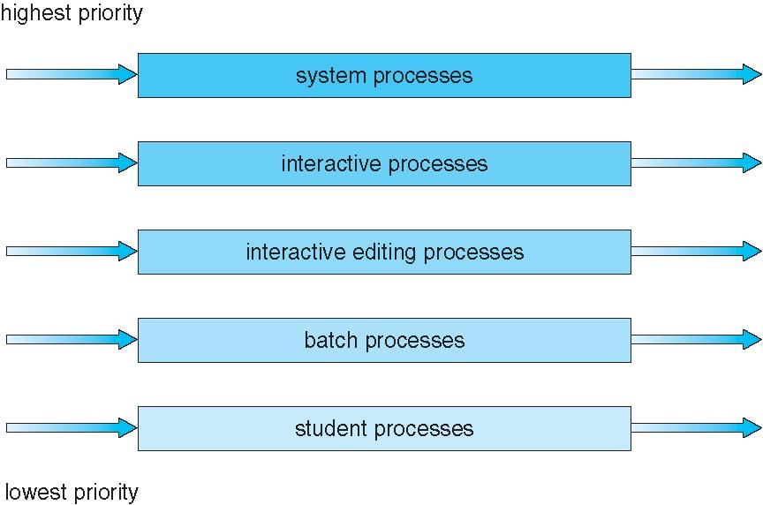
- Multi-Processor Scheduling
  - SMP/AMP
    - Symmetric multiprocessing: each processor is self-scheduling
    - Asymmetric multiprocessing: only one processor accesses the system data structures
  - Soft/Hard Affinity
    - Processor affinity: process has affinity for processor on which it is currently running
    - Soft affinity:
    - Hard affinity:
  - Load balancing
    - Attempts to keep workload evenly distributed
    - Push migration and pull migration
- Real-Time CPU Scheduling
  - Hard/Soft Real-Time systems
    - Soft: no guarantee as to when critical real-time process will be scheduled
    - Hard: task must be serviced by its deadline
  - Rate Monotonic (RM)
    - Priority is assigned based on the inverse of its period
  - Earliest Deadline First (EDF)
    - Priority is assigned according to deadlines

Practice Exercises
Chapter 1

- What are the three main purposes of an operating system?

- Keeping in mind the various definitions of operating system, consider whether the operating system should include applications such as Web browsers and mail programs. Argue both that it should and that it should not, and support your answers.

- How does the distinction between kernel mode and user mode function as a rudimentary form of protection (security) system?

- Give two reasons why caches are useful. What problems do they solve? What problems do they cause? If a cache can be made as large as the device for which it is caching (for instance, a cache as large as a disk), why not make it that large and eliminate the device?

- Distinguish between the client–server and peer-to-peer models of distributed systems.

Chapter 2

- What is the purpose of system calls?

- What are the five major activities of an operating system with regard to process management?

- What is the purpose of the command interpreter? Why is it usually separate from the kernel?

- What is the purpose of system programs?

- Why do some systems store the operating system in firmware, while others store it on disk?

Chapter 3

- The Sun UltraSPARC processor has multiple register sets. Describe what happens when a context switch occurs if the new context is already loaded into one of the register sets. What happens if the new context is in memory rather than in a register set and all the register sets are in use?

- When a process creates a new process using the fork() operation, which of the following state is shared between the parent process and the child process?

- Stack
- Heap
- Shared Memory
- Original versions of Apple’s mobile iOS operating system provided no means of concurrent processing. Discuss three major complications that concurrent processing adds to an operating system.

- With respect to the RPC mechanisms, consider the “exactly once” semantic. Does the algorithm for implementing this semantic execute correctly even if the ACK message back to the client is lost due to a network problem? Describe the sequence of messages and discuss whether “exactly once” is still preserved.

Chapter 4

- Provide three programming examples in which multithreading provides better performance than a single-threaded solution.

- Describe the actions taken by a kernel to context-switch between kernel level threads.

- What are two differences between user-level threads and kernel-level threads? Under what circumstances is one type better than the other?

- What resources are used when a thread is created? How do they differ from those used when a process is created?

Chapter 5

- What is the meaning of the term busy waiting? What other kinds of waiting are there in an operating system? Can busy waiting be avoided altogether? Explain your answer.

- Explain why spinlocks are not appropriate for single-processor systems yet are often used in multiprocessor systems.

- Show that, if the wait() and signal() semaphore operations are not executed atomically, then mutual exclusion may be violated.

- Illustrate how a binary semaphore can be used to implement mutual exclusion among n processes.

Chapter 6

- Explain the difference between preemptive and non-preemptive scheduling.

- What advantage is there in having different time-quantum sizes at different levels of a multilevel queueing system?

- Suppose that a scheduling algorithm (at the level of short-term CPU scheduling) favors those processes that have used the least processor time in the recent past. Why will this algorithm favor I/O-bound programs and yet not permanently starve CPU-bound programs?

- Distinguish between PCS and SCS scheduling.

